Table of Contents
1 Introduction 1
2 Top-down layered static view 2
3 Detailed design of the gpio_service module. 3
3.1 LEDControl Class 3
3.1.1 Purpose 3
3.1.2 Design & Threading 3
3.1.3 API Reference 4
3.1.3.1 LEDS Constants 4
3.1.3.2 Methods: 4
3.1.4 Error handling 6
3.2 Module test 6

Introduction

The LED’s on the front panel are behind the touch buttons. The main functions of the LED’s are:
- During power-ON-boot cycle the STOP_LED is on, to indicate that boot cycle is active.
- When Oradio is being initialized during starting up, the STOP_LED is blinking until Oradio is ready to use.
- All LED’s are off ( or in backlight off) when Oradio is ready.
- When a touch button is touched or pressed the related touch button led will be on.
- To indicate a special state one of the LED’s may start blinking:
  - When Oradio Access Point is active: the PLAY button is blinking
  - When an error condition is found: the STOP button is blinking
There is a background process (backlight) that manages the “off” and “on” light level of the LED’s. This backlight level is controlled by a daylight sensor, to improve the visibility of the LED’s when environmental light conditions are changing.
The backlight control is not part of this description.

Top-down layered static view
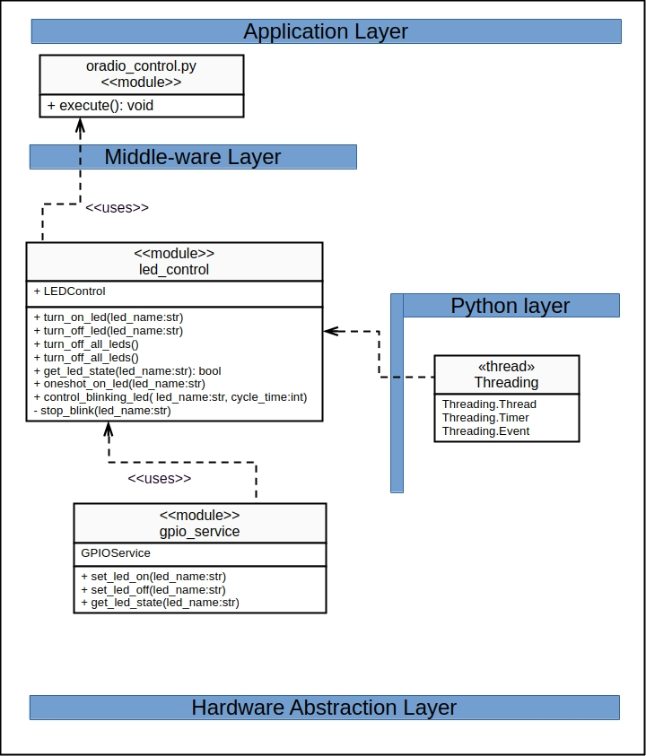

The Oradio3 software layering typically consists of three main layers:
- the hardware abstraction layer (HAL), which includes the physical components.
- the middle-ware layer, which facilitates communication and data management between the hardware and applications. The OS services is considered to be part of this layer
- the application layer, where the actual software applications run and perform specific tasks.
The Python Layer is a supporting layer to include Python modules and libraries.

The LEDControl class is a Oradio3 module offering services to turn on or off a specific LED. It imports the GPIOService class, which provides a wrapper for the physical writing to I/O pins assigned to the LED’s
The LEDControl uses the Python Threading for timers, threads and event handling.

Detailed design of the led_control module.

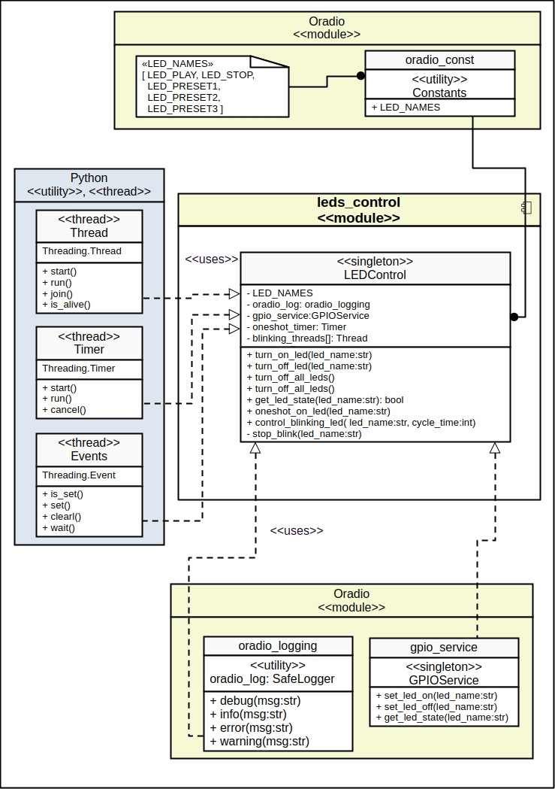
LEDControl Class

Purpose
- Provides methods to control the state of the LED’s
- Manages and reports (logging) LED’s related errors and warnings.

Design & Threading
- Singleton: Restricts the class to a single instance, to offer a single point of access for the led controls.
- Threads: Blinking support for each LED is managed by a thread. Each LED blinking thread is running until it is stopped. The blinking thread uses an eventing mechanism to turn on and off the led periodically.
- Timers: For the turning on a led for a specific period (one-shot) a Threading.timer is used
- Events: The blinking thread uses Event.wait() function for a half-period to turn a led on or off. As long as the event is active the eventing proceeds in the thread. When event is stopped the thread is also stopped.
- Logging: For logging purposes the oradio.SafeLogger utility is used offered by oradio_logging module.
- GPIOService: creates an instance of the GPIOService class to use methods which sets the physical LED-pin on or off.

Design decision:
The blinking of a led is started with method control_blinking_led(). The blinking is stopped by the application by either turning on or off the related led. There is no method provided to stop the blinking.

API Reference

LEDS Constants

LED_PLAY = "LedPlay"
LED_STOP = "LedStop"
LED_PRESET1 = "LedPreset1"
LED_PRESET2 = "LedPreset2"
LED_PRESET3 = "LedPreset3"
LED_NAMES =[LED_PLAY, LED_STOP, LED_PRESET1, LED_PRESET2, LED_PRESET3]

Methods:

Method | Arguments | Returns
LEDControl.turn_off_led | (led_name: str) | None
Description:
- Turning OFF of the specified led (led_name).
- led_name = [LED_PLAY | LED_STOP | LED_PRESET1 | LED_PRESET2 | LED_PRESET3]
Errors:
- (“Invalid LED name: %s", led_name)

Method | Arguments | Returns
LEDControl.turn_on_led | (led_name: str) | None
Description:
- Turning ON of the specified led (led_name).
- led_name = [LED_PLAY | LED_STOP | LED_PRESET1 | LED_PRESET2 | LED_PRESET3]
Errors:
- (“Invalid LED name: %s", led_name)

Method | Arguments | Returns
LEDControl.turn_off_all_leds | () | None
Description:
Turning OFF all led’s
Errors:

Method | Arguments | Returns
LEDControl.turn_on_all_leds | () | None
Description:
Turning ON all led’s
Errors:

Method | Arguments | Returns
LEDControl.oneshot_on_led | (led_name: str, period: float=3) | None
Description:
Turns ON specified led (led_name) for specified duration (period) and the turns off the specified led.
- led_name = [LED_PLAY | LED_STOP | LED_PRESET1 | LED_PRESET2 | LED_PRESET3]
- period = a float, with as default value 3
Errors:
- (“Invalid LED name: %s", led_name)
- ("Invalid period time of %f for one-shot of led: %s", period, led_name)

Method | Arguments | Returns
LEDControl.get_led_state | (led_name: str) | - True for led in ON state,  - False for led in OFF state  - None for unknown led name
Description:
Reads and returns the actual state of a led
- led_name = LED_PLAY | LED_STOP | LED_PRESET1 | LED_PRESET2 | LED_PRESET3]
Errors:
- (“Unknown LED name: %s", led_name)

Method | Arguments | Returns
LEDControl.control_blinking_led | (led_name: str, cycle_time: float=2) | None
Description:
Start blinking of specified led (led_name)
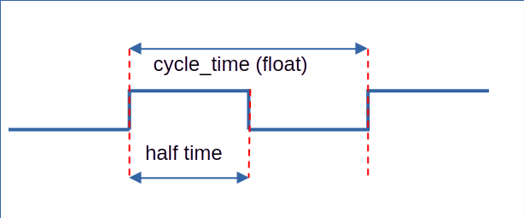
- led_name = [LED_PLAY | LED_STOP | LED_PRESET1 | LED_PRESET2 | LED_PRESET3]
- cycle_time = a float, with as default value 2
Errors:
- (“Invalid LED name: %s", led_name)

Error handling
- All errors are logged using the oradio_log.error or .warning utility of oradio_logging.py

Module test
There is a module test program <led_control_test.py> that will provide following tests to test the methods of the class:
- All led’s ON or OFF
- All led’s blinking, with adjustable cycle-time
- A one-shot cycle for All led’s, with adjustable one-shot timing
- A single led test:
  - Turn ON or OFF a selected led,
  - One-shot for a selected led,
  - Blinking for a selected led.
  - Unknown led error handling

